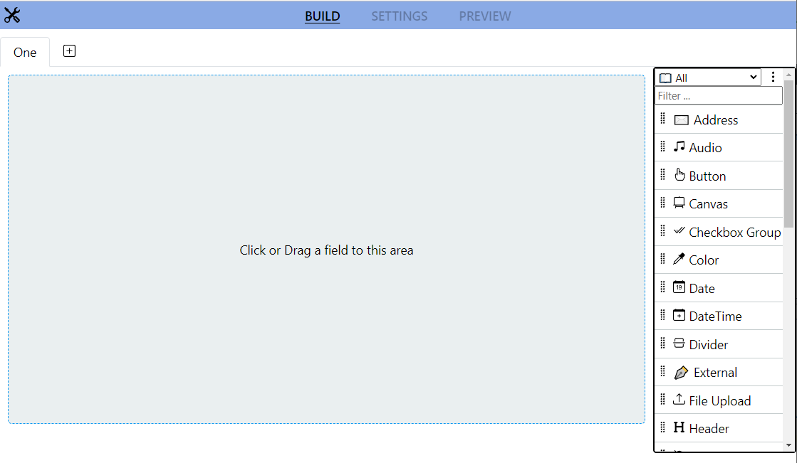

Component Selection

Form Stage

Tabs

Tools

Views

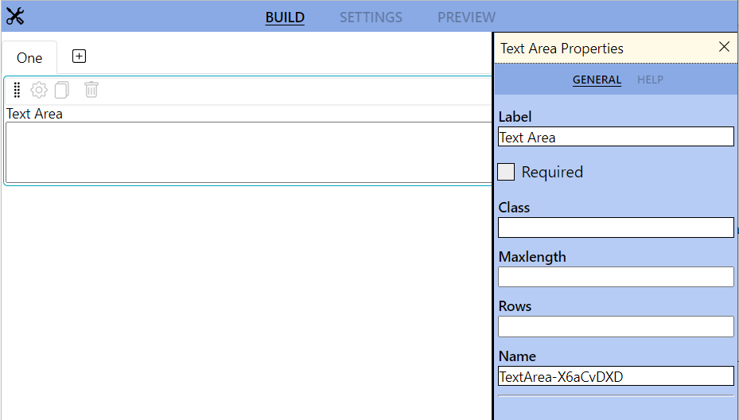

Component/Field

Quick Menu

Property Panel